Ideation Phase
Define the Problem Statements

Date | 15 FEB 2026
Team ID | LTVIP2026TMIDS47541
Project Name | OrderOnTheGo
Maximum Marks | 2 Marks

Customer Problem Statement Template:
To define the core problems faced by users and restaurant owners in local food ordering scenarios, and use those insights to guide the development of OrderOnTheGo.
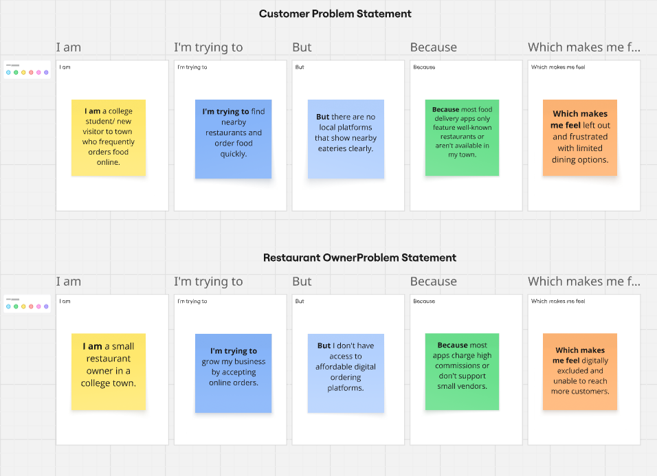

Problem Statement (PS) | I am (Customer) | I’m trying to | But | Because | Which makes me feel
PS-1 | I am a college student/ new visitor to town who frequently orders food online. | find nearby restaurants with good food | there is no dedicated platform for local options | big food delivery apps don’t support smaller towns/restaurants | left out, with limited choices
PS-2 | a restaurant owner in a local area | reach more customers and manage online orders | I don’t have access to any digital ordering system | most platforms are expensive or don’t onboard small vendors | helpless and digitally excluded

